Name: <your name>

Project number: 21759407

IDE name: Eclipse Oxygen.3a Release (4.7.3a)

Operating system: Windows 10

Instructions to set-up and run project:

1. Go to <https://javaee.github.io/glassfish/download> and download glassfish: “[GlassFish 4.1.2 - Full Platform](http://download.java.net/glassfish/4.1.2/release/glassfish-4.1.2.zip)”
2. Unarchive the downloaded file and copy it to C:\glassfish4.
3. Unarchive provided bookmarks.7z somewhere on the Desktop. Identify the **unarchived bookmarks** folder.
4. Navigate to C:\glassfish4\docs\javaee-tutorial\examples\web\jsf
5. Paste the **unarchived** **bookmarks** folder from the Desktop in the C:\glassfish4\docs\javaee-tutorial\examples\web\jsf folder and replace all.
6. In Eclipse, import all projects from the jsf project of the glassfish examples: Eclipse -> File -> Import -> Type “maven” -> Double-click “Existing Maven Project” -> Browse -> Navigate to: C:\glassfish4\docs\javaee-tutorial\examples -> Click “Select All” -> Finish
7. In the Project Explorer, expand to: javaeetutorial -> web -> jsf -> bookmarks
8. See modifications
9. Changes done to the bookmarks project
   1. Added 1 radio button group, 1 checkbox, 1 list box
   2. Changed the graphical image from: Duke waving to: Duke thumbs up
   3. Added a table to the response page.

For more information on this, check Chapter 4, which contains detailed information about the changes.

1. Proof of compilation

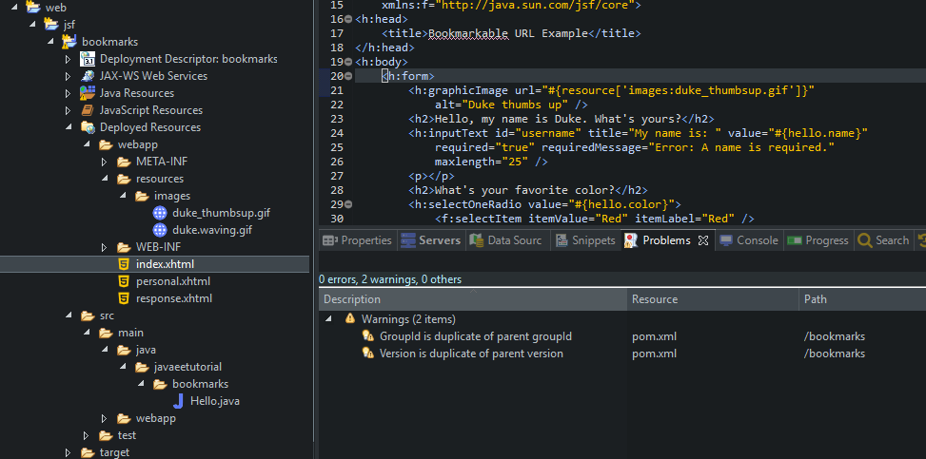

Figure Screenshot showing correct compilation of code

1. How it works:
   1. Select index.xhtml -> right-click -> Run-as -> Run on Server -> Glassfish
   2. Wait a few seconds for the server to start
   3. Go to your preferred browser and paste this address: <http://localhost:8080/bookmarks/index.xhtml>
   4. The index page now looks like this:

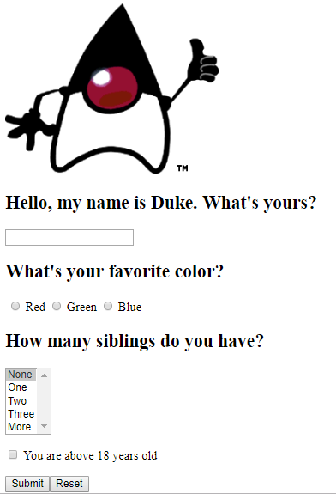

Figure The index page with added controls

* 1. Input the Name input box, select your favorite color in the radio, select the number of siblings in the list box, and check the checkbox whether you are above 18
  2. Press Submit
  3. The response page is displayed containing the data you input before. In addition, it contains some predefined grades in a table, at the bottom of the page.

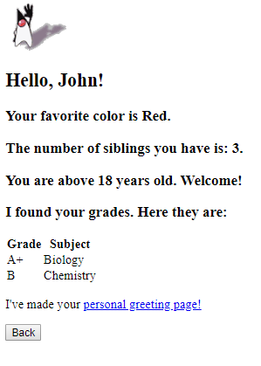

Figure Response page containing the information from the stating page

* 1. Press the ‘Personal greeting page’ link to go to the **Personal** page. You can see the same information in a different way

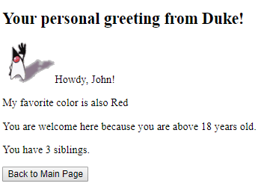

Figure Personal page containing the input information

1. Detailed changes:
   1. Extended Hello class:

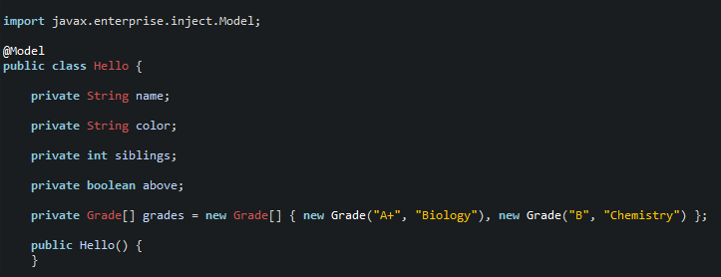

Figure The updated Hello class

* 1. New Duke image

Downloaded a new gif (duke_thumbsup.gif) and placed in the resources/images folder:

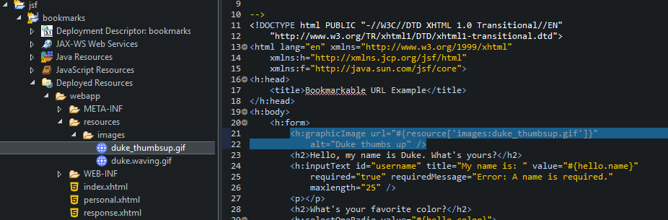

Figure Duke thumbs up image

This has as result a new Duke image on the index page:

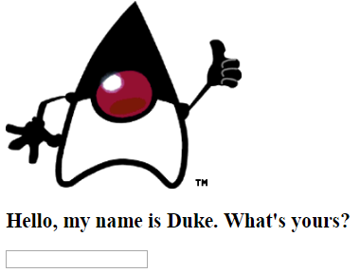

Figure Duke after



Figure Duke before

* 1. New radio buttons group in index page:

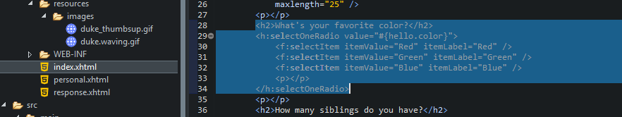

Figure Index.xhtml: New radio button grop containing colors

* 1. Favorite color displayed in response and personal pages:

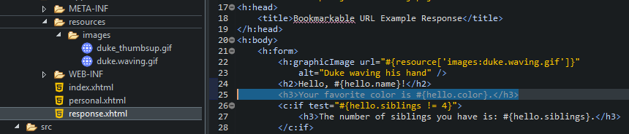

Figure response.xhtml Favorite color displayed

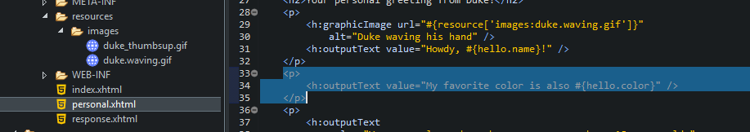

Figure personal.xhtml Favorite color displayed

* 1. New list box in the index page:

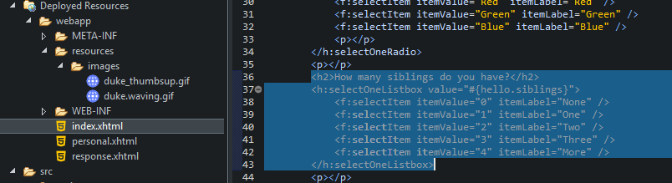

Figure Index.xhtml: New list box containing numbers of siblings

Notice that the itemValues are 0, 1, 2, 3, 4 and the labels are None, One, Two, Three, More. This means that None has a value of 0 and More has a value of 4.

* 1. Siblings displayed in response and personal pages:

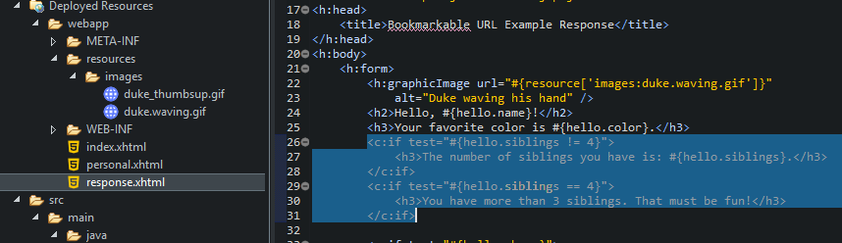

, when the user selected “Two” in the index page

, when the user selected “More” in the index page

Figure response.xhtml Siblings displayed

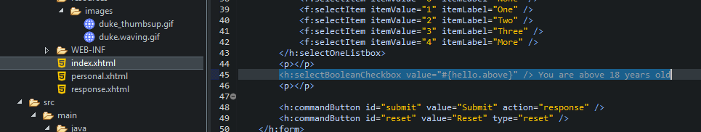

Figure Index.xhtml: New checkbox defining whether your age is above 18

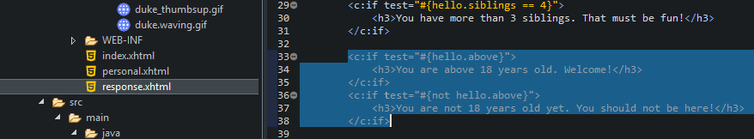

, when the user selected the “Above 18” checkbox

, when the user didn’t select the “Above 18” checkbox

Figure response.xhtml: Displays whether above 18 years old

* 1. New table displayed in the response page:

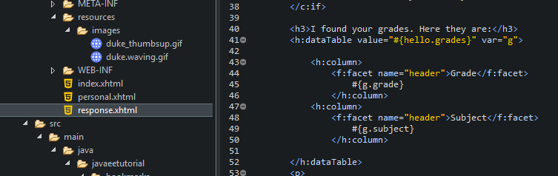

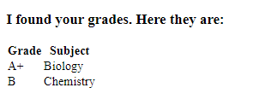

Figure response.xhtml: Grades displayed

* 1. For this to work, I created a new class Grade and added it to the Hello class:

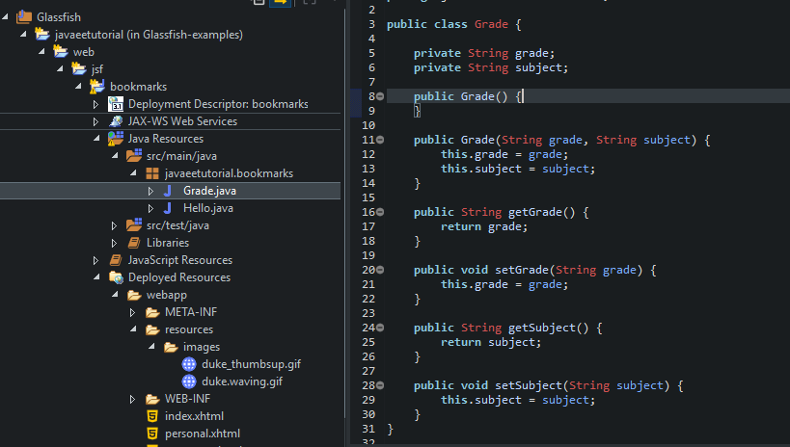

Figure New class Grade, containing the actual Grade and Subject

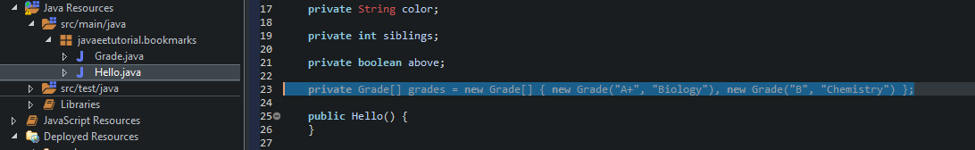

Figure The Grades array in the Hello class